project planning phase

Date | 4-11-2025
Team ID | NM2025TMID02289
Project Name | Educational Organization Using ServiceNow
Maximum Marks | 5 Marks

Project Planning: Educational Organization Using ServiceNow

Product Backlog

The product backlog for the “Educational Organisation Using ServiceNow” project contains all the key features and requirements identified to streamline academic and administrative operations. Major backlog items include student information management, course registration workflows, staff and faculty service portals, attendance automation, IT support ticketing, and performance reporting dashboards. Each feature is prioritized based on institutional needs, value addition, and implementation complexity. The backlog is a dynamic document maintained by the product owner, ensuring continuous refinement as user feedback and new institutional requirements emerge.

Sprint Planning
During sprint planning, the development team, product owner, and scrum master collaborate to define clear sprint goals and select prioritized backlog items that can be completed within the sprint duration. For this project, each sprint is planned for two weeks, focusing on delivering incremental functionality, such as building a course registration module or integrating faculty service requests. The team evaluates capacity, dependencies, and risks to ensure realistic planning.

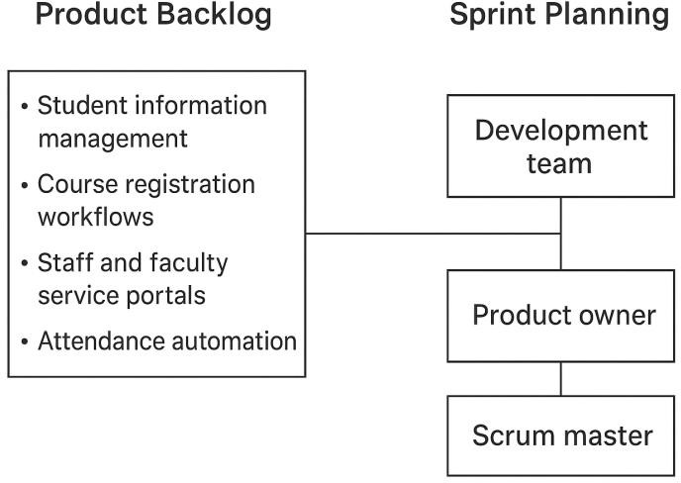

User Stories
User stories are crafted to capture the specific needs of end-users in simple, goal-oriented language. Examples include:
- As a student, I want to submit service requests through a self-service portal so that I can get support quickly.
- As a faculty member, I want to automate class attendance tracking to save administrative time.
- As an administrator, I want to generate real-time reports on student services to monitor institutional efficiency.
Each story focuses on delivering measurable value and is small enough to be completed within a sprint, ensuring consistent progress and stakeholder satisfaction.

Story Points

Story points are assigned to each user story to estimate the relative effort and complexity involved in implementation. Using a Fibonacci scale (1, 2, 3, 5, 8, 13), the development team evaluates factors such as technical difficulty, dependencies, and potential risks. For example, configuring a simple student form may be assigned 2 points, while integrating ServiceNow with external

academic databases may require 8 points. Story point estimation helps in forecasting team velocity, managing workloads effectively, and improving planning accuracy over time.

